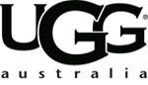
UGG Australia Authorized Retail Stores
Queensland Gold Coast Brand Discount Zone
30/11/2012 16:36 PM
VIP No:112496000113
Salesman:073
PURCHASE
UGG BOOTS: Mens Bailey Button 5775 Chestnut US12
The Cost Price:130$
Discount:70$
GST amount included in price :60$
Quantity: 1
Total : 60$
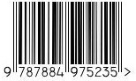

THANKYOUFORSHOPPING

